Generating Image
Generate a farmer harvesting in south India – free style prompting
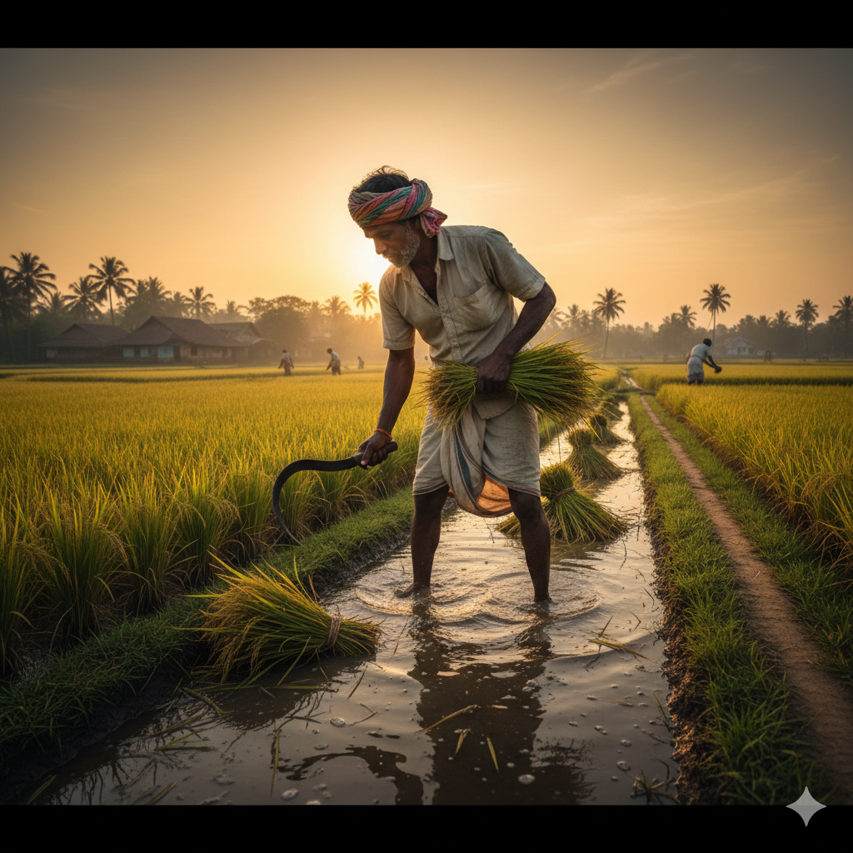

JSON prompting
{
"prompt": "A realistic, cinematic scene of a South Indian farmer harvesting rice in a lush paddy field. The farmer wears traditional attire (veshti/dhoti and cotton shirt), bending slightly while cutting golden rice stalks with a sickle. Coconut trees line the horizon, with distant hills and a warm morning sky. Water-filled paddies reflect soft sunlight, evoking rural South India’s agricultural heritage. Ultra-detailed, natural colors, documentary photography style.",
"style": "photorealistic",
"camera": "wide-angle, eye-level",
"lighting": "soft natural sunlight, early morning",
"mood": "hard work, tradition, harmony with nature",
"aspect_ratio": "16:9",
"quality": "high",
"transparent_background": false
}
